Directories Submission:
S.no | URL | Dcfieldtrips Screenshot
01 | http://www.directoryfever.com/submit.php?c=21&LINK_TYPE=2 | 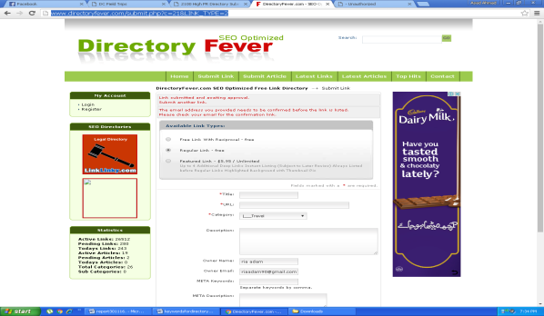
02 | http://www.omcommunication.net/submit.php?c=667 | 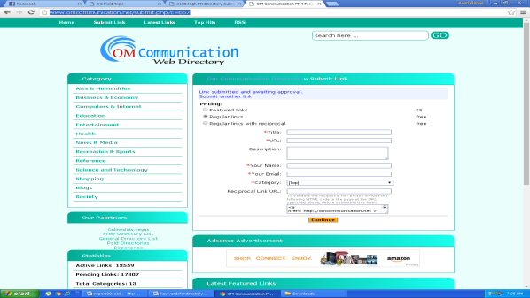
03 | http://www.contentclear.org/submit.php?c=667 | 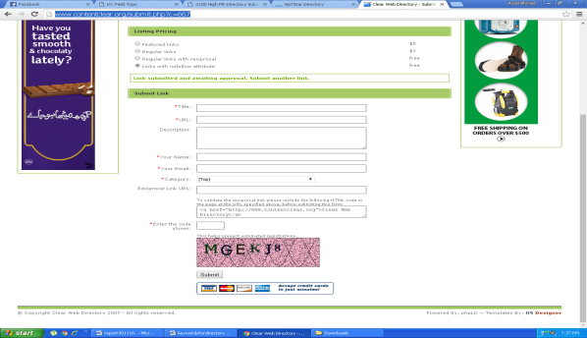
04 | http://www.webdirectory1.biz/add.php | 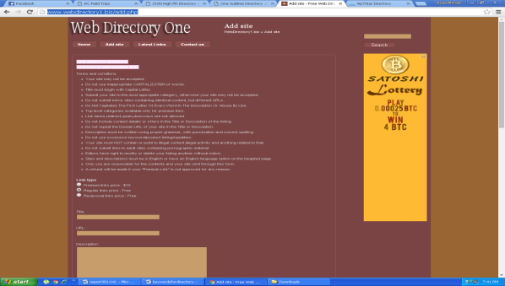
05 | http://www.one-sublime-directory.com/submit.php?c=286 | 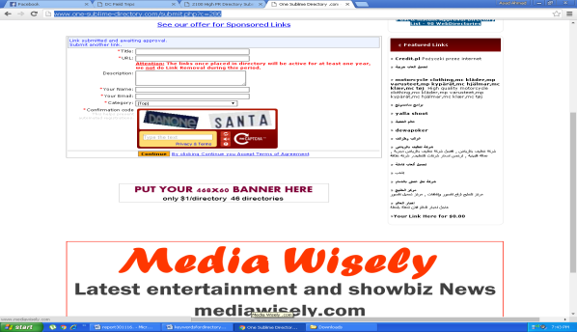
06 | http://www.mydannyseo.com/submit-url | 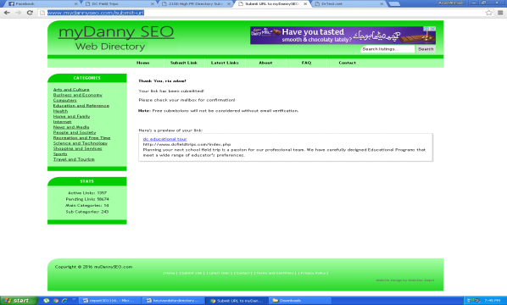
07 | http://www.drtest.net/submit-url | 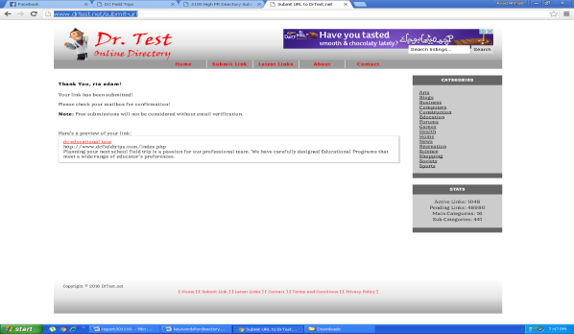
08 | http://www.fivestarsautopawn.com/submit-url | 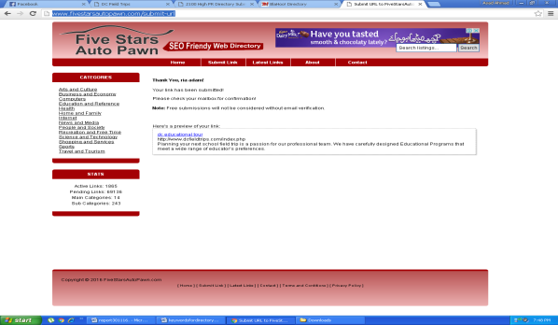
09 | http://www.directory5.org/submit.php?c=20 | 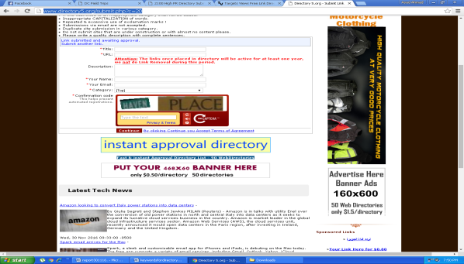
10 | http://www.targetsviews.com/store-url.php | 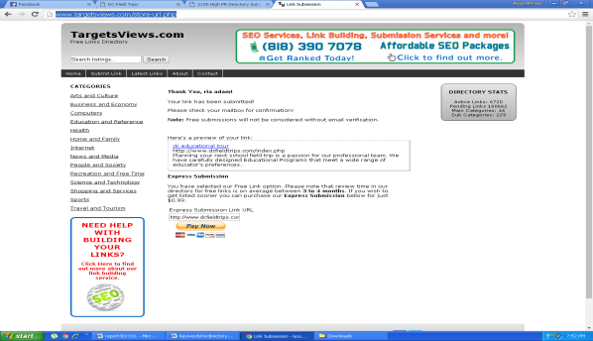
11 | http://www.directory3.org/submit.php?c=17 | 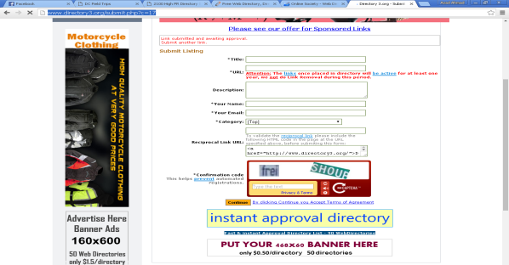
12 | http://www.onlinesociety.org/submit.php?c=146&LINK_TYPE=2 | 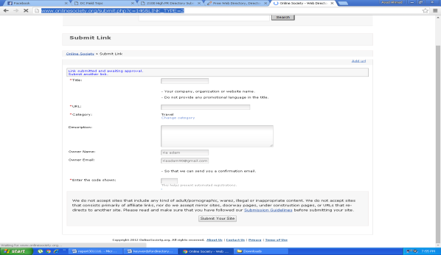
13 | http://www.postfreedirectory.com/submit
14 | http://www.phillyfirstonthefourth.com/thankyou.html | 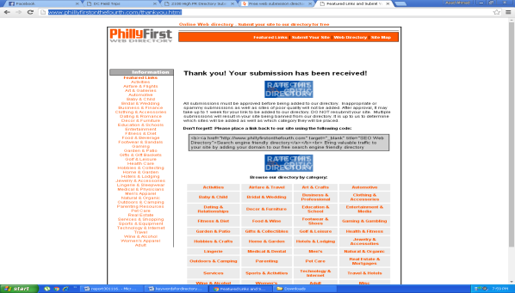
15 | http://www.bestdirectory4you.com/submit.php?c=312&LINK_TYPE=2 | 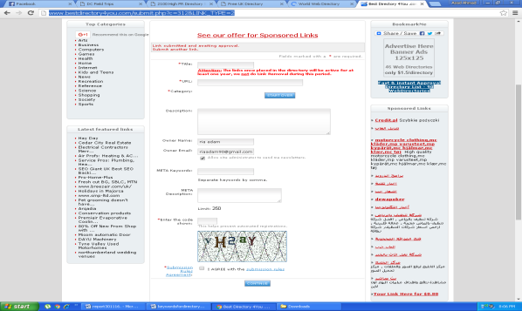
16 | http://www.worldweb-directory.com/add.php?c=435 | 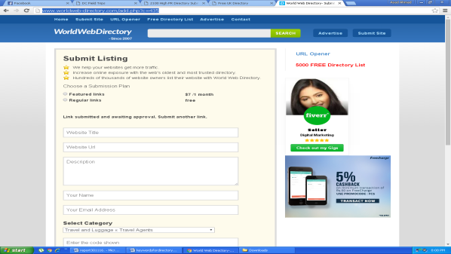
17 | http://www.dracodirectory.com/index.php?adds=546
18 | http://wldirectory.com/submit.php?c=667 | 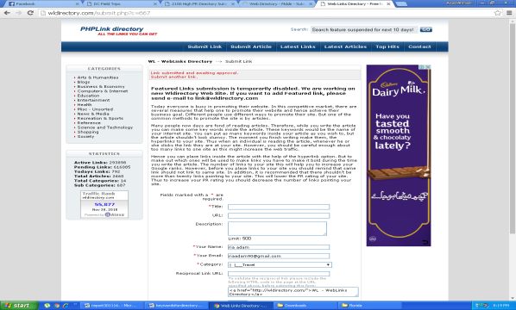
19 | http://www.bestseodirectory.net/submit.php?c=1305&LINK_TYPE=2 | 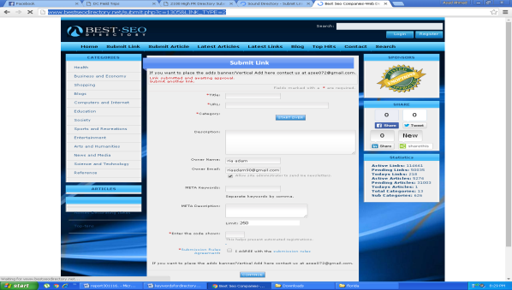
20 | http://www.sound-directory.com/submit.php | 